IREVELOTION: A DATA-DRIVEN EXPLORATION OF APPLE'S IPHONE IMPACT IN INDIA

**PROJECT REPORT**

# INTRODUCTION

1.1 OVERVIEW

IPhone manufacturing in India allows Apple to by pass hefty import duties, thereby reducing the cost of the product for the Indian consumer. This move makes the brand more accessible to a broader demographic within the country, where price sensitivity is a key factor in consumer decisions. By producing iPhones locally, Apple is likely to strengthen its market share in India’s burgeoning smartphone market.

## Purpose:

Apple tripled India iPhone output to $7 billion in the ﬁscal year ending March 31, 2023 and was

reportedly now making almost 7% of its iPhones in India. Apple's sales in India hit a new high of about $6 billion in the ﬁscal year, up nearly 50% from a year earlier, showcasing the increasing importance of

iPhones in a country that emerged to be the fastest growing major economy.

# PROBLEM DEFINITION& DESIGN THINKING

## EMPATHY MAP



* 1. **BRAINSTROMING MAP**

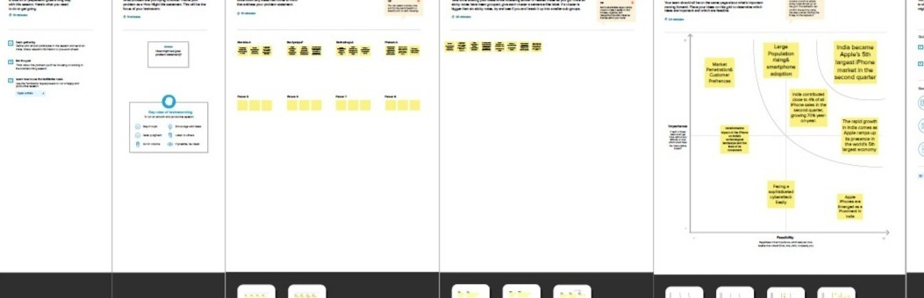

## RESULT

Strong results driven by iPhone’s sale', registers 61% growth in India's smartphone market Apple, which opened its first India stores this year, views the fast-growing market as both a retail opportunity and an important production base for its gadgets in the longer term. In the quarter through June, iPhone sales in India grew at a double-digit rate to a new high, Apple said without revealing precise numbers.

1. **ADVANTAGES**

* In the long term, local sourcing and manufacturing of iPhone components will help further stimulate local Indian economies and lower production costs. Finally, Apple and Foxconn’s demonstrated conﬁdence in India’s technological manufacturing capabilities will encourage further investments.

* Apple is contributing to the nation's industrial growth, inculcating technological innovation, and creating thousands of jobs

## Disadvantages:

* Problem with the iPhone's battery life.

* It does not easily ﬁt in many cell phone cases available for purchase.

* iPhones can easily get lost or stolen because they do not have a Find My Phone function that comes with many android phones.

*There's no multitasking aspect available on the iPhone, which means it will perform slower than an Android phone.

*There is no way to expand the iPhone's memory without purchasing it from Apple separately

## 6) Conclusion:

The decision to manufacture iPhones in India has proven to be a game-changer in the tech industry. It has not only provided Apple with cost advantages and a larger consumer base but has also contributed to India’s economic growth and skill development. The localization of production has made iPhones more affordable for Indian consumers while attracting foreign investment to the country. As India continues its journey to become a globalmanufacturing powerhouse, the presence of Apple and other tech giants will undoubtedly play a crucial role in shaping its future.

7) Future Scope:

Apple is one of the biggest companies in the smartphone world and has a very strong user base which is ever growing and will keep doing so. The future of the iOS developers are going to be very bright and this market going to boom in coming years.